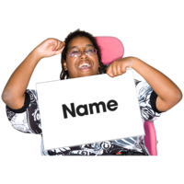
Building People Change Minds Application Form:
Easy Read
- What is your first name?

- What is your second name?
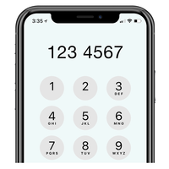
- What is your phone number?

- What is your email address?

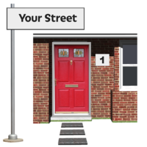
- What is your home address?

7. Which part of Lewisham do you live in?
(please choose from the list below)

Bellingham
Blackheath
Brockley
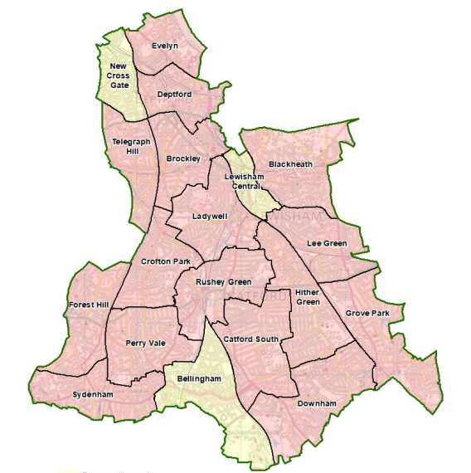
Catford South
Crofton Park
Deptford
Downham
Evelyn
Forest Hill
Grove Park
Hither Green
Ladywell
Lee Green
Lewisham Central
New Cross Gate
Perry Vale
Rushey Green
Sydenham
Telegraph Hill

8. Which of these best describes you?
- I have a learning disability
- I have mental ill health
- I am autistic
- Something else (please say below)

9. Who referred you to this project?
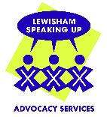
Lewisham Speaking Up

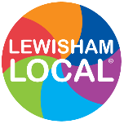
Lewisham Local

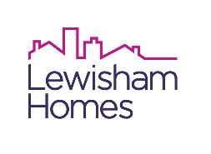
Lewisham Homes

Someone else (please say below)

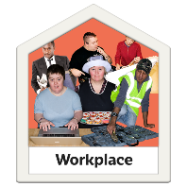
10. What sort of work do you want to do? (you can tick as many as you like)
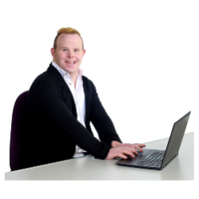
Office work


Art (painting, drawing, art workshops)

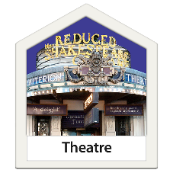
Theatre

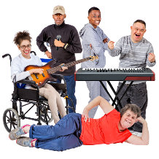

Music

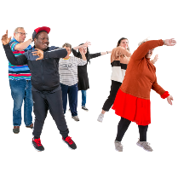
Dance

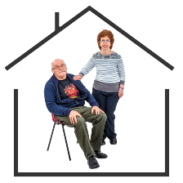
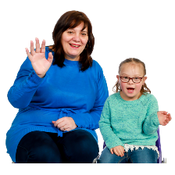
Helping other people (e.g. helping older people, helping children)

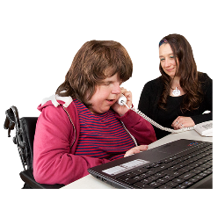
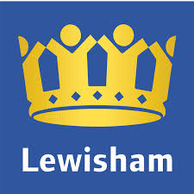
Working with the Council

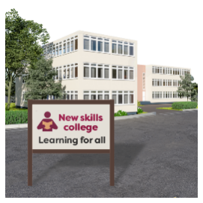

Working in a school or a college

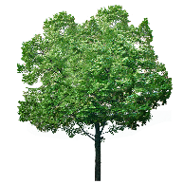
Working outside (e.g. in a park, helping with the environment)

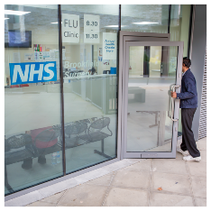
Health work


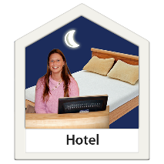
In a café, restaurant, or hotel (we call this ‘hospitality’)


Working with computers

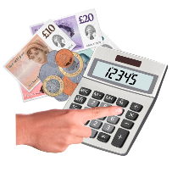
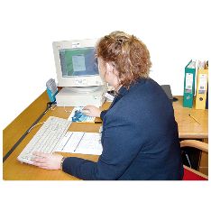

Working with money

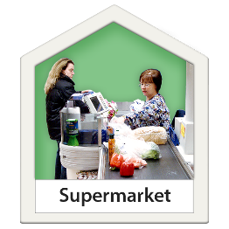

In a shop

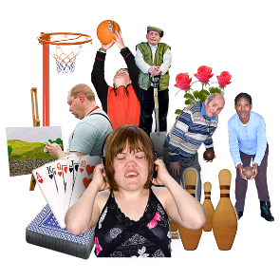
Sports

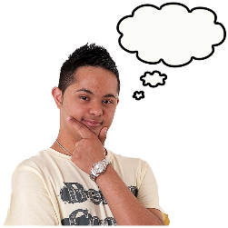
Something else (please say below)


What skills do you have? These are things that you are good at and that you like to do. (please say below)

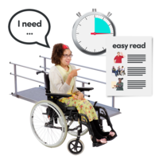
What changes do we need to make to help you do the job? This might be extra help that you need. Some people call this a ‘reasonable adjustment’. (please say below)

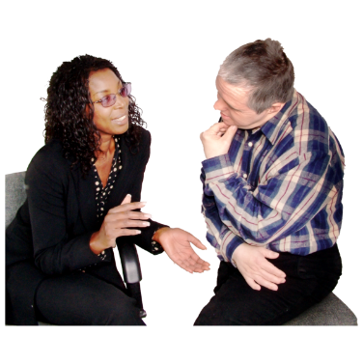
Is there anything else we need to know about you, so we can give you good support?

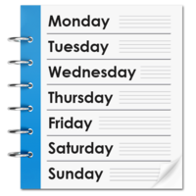
How many days a week would you like your placement to be? You can do as little as one day a week and as much as five.

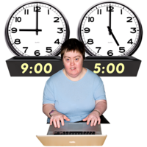
How many hours a day would you like your placement to be? This can be as little as 6 hours and as much as 35 hours a week.

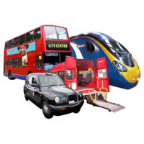
Can you use public transport?
Yes or No

Which areas of Lewisham would you most like to do your placement in? (please choose areas that are good for you)
Bellingham
Blackheath
Brockley
Catford South
Crofton Park
Deptford
Downham
Evelyn
Forest Hill
Grove Park
Hither Green
Ladywell
Lee Green
Lewisham Central
New Cross Gate
Perry Vale
Rushey Green
Sydenham
Telegraph Hill

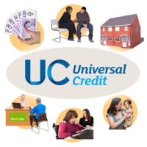
Do you currently receive any government income? Please put which ones you receive in bold
Employment and Support Allowance (ESA)
Personal Independence Payment (PIP)
Disability Living Allowance for Children
Attendance Allowance
Carer’s Allowance
Other (please tell us what below)

Does this impact the amount of time you can volunteer?

Yes or No

Please sign your name below:

